Hungarian Energy Policy and Politics
Nick E. Gilewski
Politics & Evaluation of Policy 720
Dr. Polka
Niagara University
March 19, 2019

Introduction to Policy and Politics
Policy exists thru ought the entire world. It controls carbon dioxide levels, environmental issues, what we ingest into our bodies, transportation, how much tax we pay, imports, exports… Policy covers nearly everything. Its application and effectiveness demonstrate what makes policy so important in the world today. Policy is about society and its people. Policy outlines our socially accepted norms (culture) and practices to assure some form of predictability and reliability in the allocation of resources so that all people can contribute towards an optimal social outcome (Lowi, 1972). Listed below are some examples, which demonstrate how diverse policy can be:
- Clean Air Act 1990 provides a healthy, productive environment, linked to sustainable economic growth and sound energy policy (Environmental Protection Agency, n.d.).
- Niagara University’s student code of conduct, which contains a list of 17 acts of conduct that are prohibited on campus (Niagara University, n.d.).
- United Kingdom Carbon Tax Policy, which was implemented in 2013, the tax is a “carbon price floor” that functions as the minimum price that fossil fuel producers pay to emit CO2 (Carbon Tax Center, n.d.).
- 2030 Climate and Energy Framework targets at least 35% share in renewable energy by 2030 (European Commission, n.d.).
- The NFL and the NFL Players Association agree: Making sure players and staff conduct themselves in a manner that honors the game and safeguards it for future generations is a priority (National Football League, 2019).
Note that 3 out of the 5 policies involves a formal government structure. Policy can be defined and utilized in many ways depending on its particular application. Here are two different definitions on what policy is: (1) Policy is defined as a course or principle of action adopted or proposed by a government, party, business, or individual (Lowi, 1972), and (2) policy is a set of ideas or plans that is used as a basis for making decisions, especially in politics, economics, or business (Collins Dictionary, n.d.). The exact definition for policy is actually somewhat subjective; however, it encompasses a common theme, which is society and people. In addition, both definitions use the verbiage “politics and government” as a vehicle to create and or promote policies.
There is political interaction and tension when creating policies. Congress, the President, the Cabinet, advisers, agency bureaucrats, federal and state courts, political parties, interest groups, the media...All of these groups interact to make political decisions in the United States (US History.org, n.d.). Similarly, in the United Kingdom the political system is a parliamentary democracy which functions under a constitutional monarchy. The monarch is the constitutional head of state, but acts mainly in a ceremonial capacity. Executive powers, the power to implement and enforce laws, lie with the Government. Government may propose a new law or piece of legislation to give legal underpinning to some or all of a policy (The British Ecological Society, 2017).
Public policy, which is very political, is a goal-oriented course of action that the government follows in dealing with a problem or issue in the country. Public policies are based on law, but many people other than legislators set them. There are three major types of public policy: regulatory policy, distributive policy, and redistributive policy. Each type has its own special purpose (Angelo State University, n.d.). In addition to public policy, energy policies are also highly politicized.
Energy policy, which is politically influenced, comprises rules concerning energy sources; energy efficiency; energy prices; energy from abroad; energy infrastructure; and climate and environmental aspects of energy production, utilization, and transit. The main theme in energy policy usually concerns trade-offs between affordable, secure, and clean energy. Energy policy is a cross-sectoral policy area; therefore, energy policy has implications for or is affected by decisions taken in adjoining policy addressing: agriculture, climate, development, economy, environment, external relations, and public health. The multi-sectoral character of energy policy is reflected in how it is proposed, adopted, implemented, and evaluated. Putting an energy policy issue on the political agenda can be attained easily, while the diversity of interests of the actor groups that are potentially affected by the proposal can delude or complicate the political policy process. The successful implementation depends on whether the energy policy measure in question is of a local, national, or international nature; and to what extent the implementation entails joint efforts by state and non-state actors. As with policy instruments adopted in any other policy area, the evaluation of an energy policy’s success is likely to vary across the different actor groups involved (Tosun, 2017). Energy policies are created reactively or proactively, depending on the given circumstances.
Reactive Policy, is just that… It is reactive, in response to a concern, problem, or emergency that needs attention immediately. It is designed to remedy problems that have already occurred or exist. Reactive policy development often happens more quickly than proactive policy, as the problems can be imperative or even urgent in nature. Reactive policy debate centers mostly on whether or not a certain policy mechanism is the best way to handle a situation, not whether or not the situation will ever become a problem (Penn State College, n.d.).
An example of a reactive policy was the Sullivan-Hoey Fire Prevention Law, which required that sprinkler systems be installed in all New York City factories. The reactive policy was a result of the Triangle Shirtwaist Company’s fire resulted in the tragic loss of nearly 150 young women and girls on March 25, 1911, in New York City (Anderson, 2014). Unfortunate events like the Triangle Shirtwaist Company fire could have been avoided if a proactive policy were in place.
Proactive policy is deliberately chosen in preventing something. In particular, proactive policy is often designed to prevent a concern, problem, or emergency from occurring. Proactive policies can be more challenging, than a reactive policy. Proactive policy is often difficult “politically” to get lawmakers to commit money and resources to a problem or situation that has not yet occurred. Even though proactive policy is difficult, you'll find many examples of proactive measures in energy and environmental policy.
An example of an environmental policy was the Montreal Protocol, which phased out chemicals that are dangerous to our Earth’s ozone layer. Chlorofluorocarbons (CFCs) were key constituents in hairsprays and refrigerants, which were found to be ripping a huge “hole” in the Earth’s protective ozone layer (Handwerk, 2010). The Montreal Protocol essentially eradicated CFC thru ought the world, because the policy was enforced internationally. Reactive and proactive policies, if proven scientifically effective, can then become a national policy like the Montreal Protocol.
National policies, like energy efficiency, are critical to job creation, economic development, reducing oil imports, improving the reliability of the electric grid, lowering energy prices, and addressing climate change and air pollution. Federal legislation, as carried out by the Department of Energy, Environmental Protection Agency, and other agencies, provides essential nationwide energy efficiency programs such as appliance and vehicle efficiency standards, ENERGY STAR® labels, tax incentives, technical assistance, and research and development of new technologies (ACEEE, n.d.). National policies encompass the world; therefore, the problem or potential problem will affect everyone. National policies are created to address some of the most detrimental circumstances, like climate change and global warming.

Hungary
As a researcher, I had an opportunity to study-abroad in Budapest, Hungary. Therefore, before delving into Hungary’s Energy Policy there are several points of information I wish to convey. When it comes to policy, with the influence of politics, one must understand Hungary’s government, because it has evolved from a communist country to a socialist democratic country.
In Hungary, government is the most important body of executive power, and the primary director of public administration. This means that it implements decisions made by Parliament, as the legislative “organ”, and it pursues realization of the goals laid out in the Government’s program. The Government is then considered the “body” of executive power, and its responsibilities and competences shall include all matters not expressly delegated by the Fundamental Law or other legislation to the responsibilities and competences of another body. The Hungarian Government comprises the Prime Minister and government ministers. The Prime Minister is the head of the Government. The Prime Minister can issue decrees to designate one or two Ministers to serve as Deputy Prime Ministers (The Hungarian Government, n.d.). This is extremely important to understand when creating any type of policy in Hungary. Like and politicized policy, one must understand the “chain of command” in order to legitimize a proposed policy.
Since its transition to a multiparty system in 1989, Hungary has enjoyed a fully competitive and democratic political system. Hungary is a parliamentary democracy with the leader of the largest party as prime minister. There is also a president who acts as head of state and is elected by the legislature. The legislative branch consists of the single-chambered National Assembly, consisting of 386 representatives elected through a combination of proportional and direct representation. Elections are held every 4 years (The Hungarian Government, n.d.).
The ruling coalition in 2001 consisted of the right-of-center Fidesz-Hungarian Civic Party (compared to the Republican Party in the U.S.), in concert with the Hungarian Democratic Party (compared to the Democratic Party in the U.S.) and the Independent Smallholders' Party (compared to the Independent Party in the U.S.). The main opposition parties were the leftist Hungarian Socialist Party and the centrist Alliance of Free Democrats. A far-right nationalist party, the Hungarian Justice and Life Party, also received 14 seats for the first time in the 1998 election. The parties differ over the emphasis and content of some key economic policy issues, which makes policy making extremely difficult. The Fidesz-based coalition, for example, supports a faster pace of economic reform than does the Socialist Party, which during its period in government from 1994-98 slowed the pace of reforms. Because all major parties are committed to Hungary's joining the European Union, however, economic policy differences are muted.
Hungary's judicial branch is headed by an independent Constitutional Court, established during the regime change of 1989 by the First Act of the Constitution. By law it is the responsibility of the Constitutional Court to guarantee that the constitution is adhered to in legal and political affairs. One important duty of the Constitutional Court is to reconcile the differences between national and international law, which is especially important in the economic and policy as Hungary prepares its laws to conform to EU standards (Nations Encyclopedia, n.d.). That being said Hungary is now being mandated to conform to the European Standards, which for an economically struggling country is inconceivable.

KKI Hungarian Energy Policy
Before discussing the Energy Policy in Hungary, there are a few limitations and delimitations Hungary has geographically, that other countries do not. Hungary is a small, land-locked Central European country with an unsustainable amount of domestic energy sources. In other words, Hungary does not have the resources to create enough energy to sustain their economy. Hungary is situated in the Carpathian Basin and is bordered by Slovakia to the north, Ukraine and Romania to the east, Serbia and Croatia to the south, Slovenia to the southwest and Austria to the west.
From an energy standpoint, the only option Hungary has it to import energy from surrounding countries to sustain their economy. In fact, according to Eurostat, in 2016 Hungary’s energy dependency rate was 58%. Therefore, the Hungarian energy policy is limited by external factors and its geographical location. Hungary lacks large-scale inland fossil fuel reserves nor has direct access to the sea for offshore wind or a gas line. Regional cooperation is imperative when procuring energy for Hungary. Sadly, Hungary is at the mercy of Russia, because Russia is the main EU supplier of crude oil, natural gas and solid fuels (Eurostat, 2016). Energy constraints have created social constraints, such as demand for reliable and secure energy supply or the need to combat energy poverty, which also shapes the grim outlook (Kulcsar, 2018).
Hungary is a member of the European Union, NATO, the OECD, the Visegrád Group, and is a Schengen state. The official language is Hungarian, also known as Magyar, which is not a shared language outside of Hungary; therefore, communication can be more complex when creating policies beyond Hungary (Knowledge Encylopedia, n.d.). As part of the European Union it is required to conform to their energy policies or be fined.
Therefore, Hungary must interpolate the European Union energy goals, put it into their own language, and create energy policies within Hungary. The interpretation of the European Union mandates will create a roadmap towards the European Union energy goals…All must be done by 2030. For example, the EU goal by 2030 is to become more Energy-efficiency projects in the building sector are a key component of the improvement of energy efficiency. In Hungary, 40 percent of all energy consumed is consumed in our buildings, two-thirds of which goes to heating and cooling. 70 percent of the approximately 4.3 million Hungarian homes fail to meet modern functional technical and thermal engineering requirements, with a similar ratio for public buildings (Janos & Pal, 2012).
Another EU energy policy is that all countries are required that 50% of its power come from a clean renewable source by 2030. Hungary, being land-locked on an island, is having a difficult time attaining that goal, because of the limited resources. However, Hungary continues to find ways to be resourceful and resilient. Therefore, Hungary created their own roadmap consisting of 132-page document titled “National Energy Strategy 2030”, which is considered the legal Energy Policy framework.
The major actions listed in the Parliamentary Decision with regard to the EU objectives of the Energy Strategy are as follows:
- Framing the Act on sustainable energy management
- Improving energy efficiency
- Increasing the utilization of renewable energy sources
- Transportation development
- Environment awareness-raising
- Achieving industry development objectives
- Ensuring the competitiveness of the district heating service
As mentioned, the “National Energy Strategy” is 132 pages and is quite complex and far-reaching. Because of the policies complexity, Hungary created an 11-page overview called “KKI Policy Brief.” The truncated version of the energy policy is much more palatable.
The “KKI Policy Brief” uses an “Energy Trilemma”, which is shown in figure 1. The energy trilemma considers 3 strategic priorities: (1) affordability, (2) supply security, and (3) environmental sustainability.
The first strategic priority is supply security, meaning the ability of the government and/or the market to ensure adequate access to energy and its products (i.e. electricity) at any given moment in time. In the case of Central Europe, this of course ties in to the role of Russian crude oil and natural gas exports to the region, and the implications of potential Russian leverage over domestic politics and business (Kulcsar, 2018).
The second strategic priority presented by the “energy trilemma” is affordability. Competitive energy prices are important both to combat poverty on a social level as well as to support domestic economic growth. In the case of Hungary, social factors are high on the policy agenda, with around 15% of the population living below the poverty line (Kulcsar, 2018).
The third strategic priority is environmental sustainability, and correlates to the fight against climate change. Although this may seem a long-term and therefore perhaps less pressing concern, mitigating and adapting to the effects of anthropogenic global warming are fast emerging as fundamental global challenges (Kulcsar, 2018). Again, Hungary is bound by the European’s ambitious goals, which limits room for maneuverability in energy affairs.

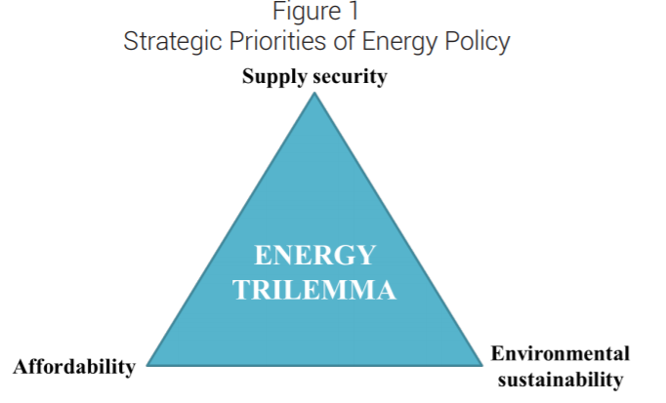
Figure 1 – Energy Trilemma (Kulcsar, 2018)

Conclusion
Firstly, in the abstract, the policy brief attempts to outline some of the main goals and challenges shaping energy policy in Hungary, utilizing the “energy trilemma.” After providing an overview of the Hungarian energy mix, it examines three strategic energy policy challenges in detail. These are Hungary’s dependence on (primarily Russian) energy imports, the role of nuclear energy, and the impacts of climate change over the long-term with a deadline of 2030. The truncated policy looks at the specific security-related concerns raised by these dilemmas, ranging from the geopolitical dynamics of Central Europe to the emergence of new security concerns, such as the cyber security of critical energy infrastructure (Kulcsar, 2018).
Secondly, the introduction provides decisions about energy and climate policy are always shaped by myriad political, economic, societal, security-related and environmental concerns. The multi-faceted nature of energy policy is particularly apparent in the case of Central Europe, where the source of Hungary’s energy imports, ties to regional players, and the role of Russia in the European energy mix are highly political and sensitive topics in domestic and foreign policy.
Thirdly, the policy provides and overview of Hungary’s current energy mix. Again, Hungary is land-locked Central European country with unsustainable amounts of domestic energy sources, the options facing Hungarian energy policy are mostly limited by external factors. Hungary lacks large-scale inland fossil fuel reserves, nor has direct access to the sea for offshore wind or a gas line, which provides a grim outlook for energy diversity. Figure 2 provides a current snapshot of Hungary’s electricity imports. Most of Hungary’s electricity is imported as shown in figure 2.

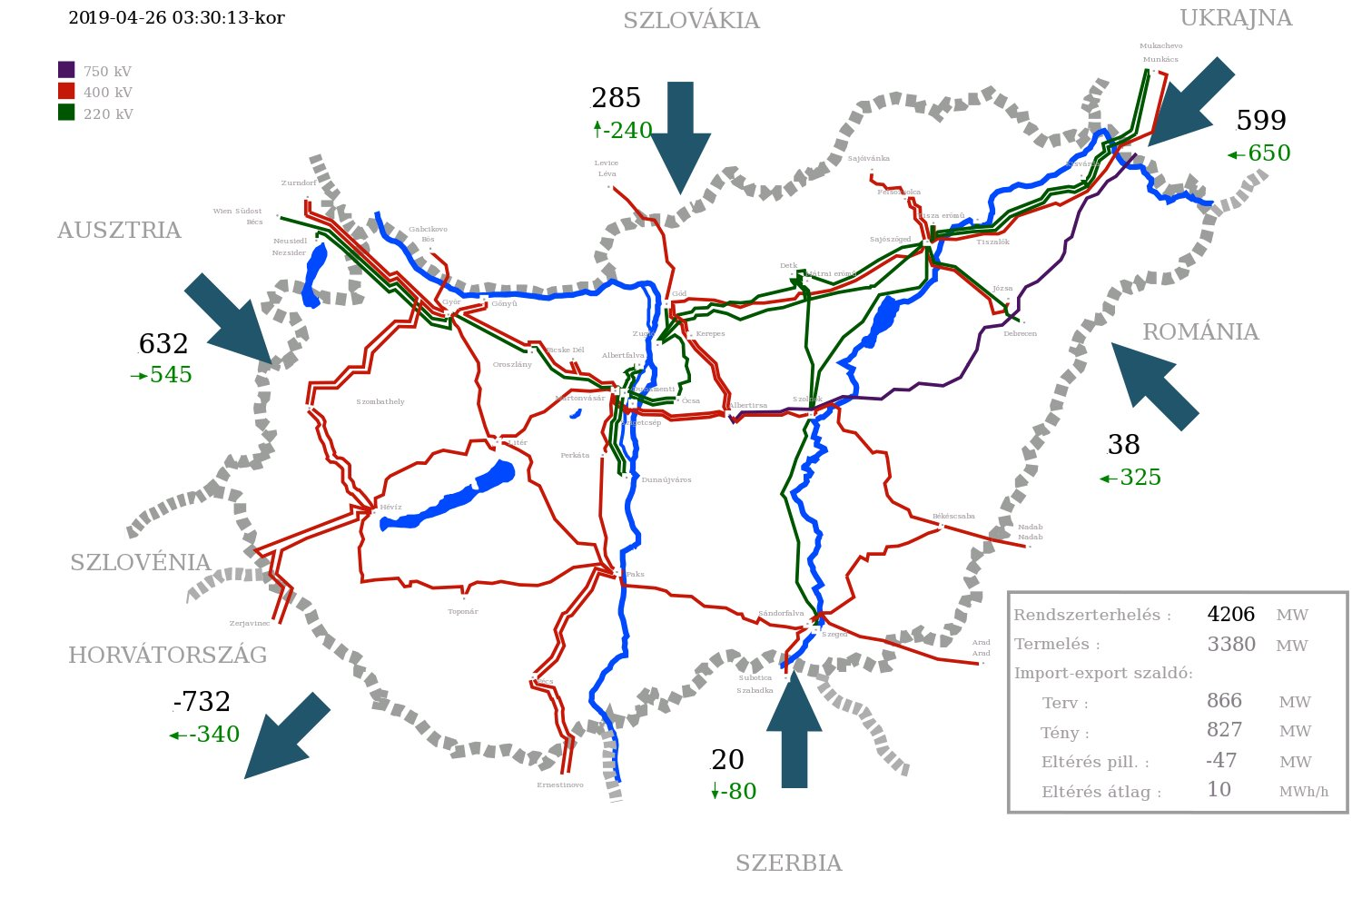

Figure 2 – Electricity Transmission (Mavir, 2019)

References
ACEEE. (n.d.). National Energy Policy. Retrieved from American Council for an Energy-Efficient Economy: https://aceee.org/portal/national-policy
Anderson, M. (2014, June 4). 25 Moments Tat Changed America. Retrieved from Time: http://time.com/3889533/25-moments-changed-america/
Angelo State University. (n.d.). Public Administrators and Public Policy. Retrieved from Public Policy: https://www.angelo.edu/faculty/ljones/gov3301/block6/objective5.htm
Carbon Tax Center. (n.d.). Where Carbon Is Taxed. Retrieved from CTC: https://www.carbontax.org/where-carbon-is-taxed/#United%20Kingdom
Collins Dictionary. (n.d.). Definition of 'Policy'. Retrieved from Collins: https://www.collinsdictionary.com/us/dictionary/english/policy
Environmental Protection Agency. (n.d.). Clean Air Act Overview. Retrieved from EPA: https://www.epa.gov/clean-air-act-overview/1990-clean-air-act-amendment-summary
European Commission. (n.d.). Climate Action. Retrieved from 2030 Climate & Energy Framework: https://ec.europa.eu/clima/policies/strategies/2030_en
Eurostat. (2016). Energy Dependency Rate (%). Retrieved from Europe Statistics: https://ec.europa.eu/eurostat/cache/infographs/energy/bloc-2c.html
Handwerk, B. (2010, May 7). Whatever Happened to the Ozone Hole? Retrieved from National Geographic: https://news.nationalgeographic.com/news/2010/05/100505-science-environment-ozone-hole-25-years/
Janos, B., & Pal, K. (2012). National Energy Strategy 2030. Retrieved from Website of the Hungarian Government: http://2010-2014.kormany.hu/download/7/d7/70000/Hungarian%20Energy%20Strategy%202030.pdf
Knowledge Encylopedia. (n.d.). Hungary. Retrieved from Knowledge Encylopedia: https://www.nationsencyclopedia.com/knowledge/Hungary.html
Kulcsar, A. T. (2018, March 20). Energy Policy Goals and Challenges for Hungary in the 21st Century. Retrieved from Institute for Foreign Affairs and Trade: https://kki.hu/assets/upload/16_KKI-elemzes_HUN_Szoke_20180423.pdf
Lowi, T. J. (1972). Public Policy 101. Public Administrative Review, 298-310. Retrieved from http://www.parachutecanada.org/downloads/policy/Policy_101.pdf
Mavir. (2019, April 23). Adatpublikáció. Retrieved from Mavir: https://www.mavir.hu/web/mavir/adatpublikacio
National Football League. (2019). NFL Rules of Enforcement. Retrieved from NFL Ops: The NFL and the NFL Players Association agree: Making sure players and staff conduct themselves in a manner that honors the game and safeguards it for future generations is a priority
Nations Encyclopedia. (n.d.). Hungary - Politics, Government, and Taxation. Retrieved from Encylopedia of the Nations: https://www.nationsencyclopedia.com/economies/Europe/Hungary-POLITICS-GOVERNMENT-AND-TAXATION.html
Niagara University. (n.d.). Student Code of Conduct. Retrieved from NU: https://www.niagara.edu/student-code-of-conduct/
Penn State College. (n.d.). Reactive and Proactive Policy. Retrieved from Energy Policy: https://www.e-education.psu.edu/geog432/node/128
Sabatier, P. A., & Weible, C. M. (2014). Theories Of The Policy Process. Boulder : Westview Press .
The British Ecological Society. (2017, May). An Introduction to Policy in the UK . Retrieved from Policy Guide: https://www.britishecologicalsociety.org/wp-content/uploads/2017/05/An-introduction-to-policymaking-in-the-UK.pdf
The Hungarian Government. (n.d.). About Hungary. Retrieved from Website of The Hungarian Government: http://www.kormany.hu/en/doc/the-hungarian-state/the-government-and-commissioners/the-government
Tosun, J. (2017, March 10). Politics - Energy Policy. Retrieved from Oxford Research Encyclopedias: http://oxfordre.com/politics/view/10.1093/acrefore/9780190228637.001.0001/acrefore-9780190228637-e-174
US History.org. (n.d.). American History. Retrieved from US Hitory: http://www.ushistory.org/gov/11.asp

