Diversity Journal 2 Entry
Nick E. Gilewski
Diversity in Organizations ADS 750
Dr. Marwaha
Niagara University
June 20, 2018

In April of 2017 I was shopping for 2X6 planks for my deck and a nice young gentleman helped me out by loading the planks into my truck. He was overly nice and kind. I decided to strike up a conversation asking him if he is in college? He said he wasn’t, but he wanted to and that he wanted to be an environmental engineer. That conversation started me on a journey I wasn’t looking for and something that I never expected.
Being brought up in a predominately white neighborhood I really didn’t have much exposure to people of color until college and then again in the military. Meeting Shaquille at Home Depot in 2017 gave me the opportunity to see how an inner city lived and acted. I submerged myself in his life helping him attend college at Niagara Community College. Without going into too many details exposing his difficult journey financially, mentally, and with his parents, I am proud to say that Shaquille finished his first year at NCCC. This experience has provided me with a perspective on what challenges Shaquille experienced growing up as an underprivileged, African American in a poor neighborhood. More importantly, Shaquille is a good kid, no different than any other person, but he just didn’t have the same opportunities that of a privileged Caucasian male with a mother and father.
I have had Shaquille over my house for Holidays, parties, and bonfires. He has spent the night several times and is welcome anytime. I treat Shaquille as if he were one of my own children.
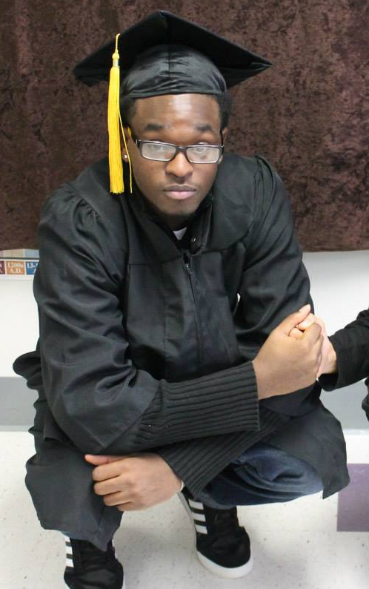
Shaquille Harrel

