ADS 840 Spring 2019 Dr. Polka
Proposed Dissertation Form for ADS 840 Spring 2019

Name: NICK GILEWSKI Date: 1/19/19
Proposed Dissertation Topic Area:
Renewable energy, and carbon emission reduction in New York State.
Proposed Dissertation Title:
New York State Clean Energy Act 2030 Roadmap – How does leadership and policy impact the trajectory. “Three Papers Essay”
Why is this Proposed Dissertation Topic and Title of Interest to YOU?
I am interested in this topic, because I am passionate about the truths and validity of green energy and climate change. Writing this dissertation will allow me to fully grasp the impact New York State leadership and policy has on going green electrically. My concern is that New York State does not have an accurate roadmap on how to obtain their 2030 goals. Moreover, if New York does meet their goals in 2030 will it be cost-effective?
Why Do YOU Believe You are One of the Best People in the World to Research This Topic at This Time?
Twenty-five years’ experience as an electrician, engineer and manager in various manufacturing facilities and the 4th largest Hydro Plant in the world. In addition, I hold a Bachelors in Electrical Engineering, a Masters Degree in Industrial Engineering and a Masters Degree in Business Administration. My experience and education have allowed me to visualize and analyze the flow of diverse power on the “Grid” in New York State from a micro and macro perspective.

What Do YOU Hope to Accomplish by Researching This Topic at This Time?
Create an accurate cost-effective Clean Energy Act 2030 roadmap for the leaders and policy makers of New York State.
What is the Benefit to YOUR Professional Field/Community of This Proposed Dissertation?
The benefit of successfully creating a useful roadmap will increase the likelihood that New York State will obtain their Clean Energy Act objectives and milestones. When, and if, New York State meets the Clean Energy Act goal, the cause and effect relationship, would be a reduction of carbon emissions making the environment we live in cleaner. Lastly, creating a useful roadmap will make me more marketable so that I can be in a leadership position to make decisions that can directly impact the future of renewable energy and carbon emission reduction.
Who are the Intended or Ultimate Users of the Findings of Your Study and SO WHAT?
The intended recipients would be Governor Cuomo and the Department of Energy. Governor Cuomo is in a position to make or propose policy changes that can directly affect renewable energy generation and carbon emissions; therefore, providing an accurate cost-effective trajectory or roadmap increasing the probability of reaching all goals by 2030. Big picture, if the roadmap is deemed effective, then it could aid and assist other states or countries.
What is the major “overarching” question that is driving you to study this topic?
Simply, this is my passion in life. Since the age of 13 I knew what I wanted to be, which was an electrical engineer. But, why stop there? Why not take everything I have learned and stood for, and make a difference by giving my research and life meaning.

Identify at Least Three Specific Research Questions, But No More Than Five, That You Hope to Answer as a Result of This Study?
- Is New York State on the correct trajectory towards accomplishing goals set forth by the New York State Clean Energy Act of 2030?
- If the goal is obtainable, will it be done in a cost-effective manner? Will money and resources increase the likelihood of obtaining the 2030 goal?
- What type of policy and leadership changes need to be made, if any, so that New York State remains steadfast on the trajectory and goal?
What is the Research Design and Methodology That You Intend To Use For Data Collection For Your Study?
Qualitative interviews, surveys and questionnaires. Descriptive study approach using GIS and SPSS. The research will consist of 2 quantitative studies and 1 qualitative study, creating a “Three Papers Essay.”
How Do You Intend to Collect the Requisite Data for This Study?
The data will be collected by conducting: research, interviews, surveys, questionnaires, and observation.
How Do You Plan to Analyze the Collected Data Related to This Study?
The research will analyze New York's current green energy policies, leadership, and trajectory using GIS and SPSS.
What is Your Conceptual Framework for This Dissertation Study?
My research title is “How does leadership and policy impact the trajectory?” Derived from the

title there are numerous sub questions that will be answered in three chapters creating a qualitative and quantitative three papers’ essay. The three papers’ essay will be comprised of 2 quantitative and 1 qualitative study.
1. Is New York State on the correct trajectory towards accomplishing goals set forth by the New York State Clean Energy Act of 2030 - Quantitative research.
2. Can the Clean Energy Act of 2030 be obtained in a cost-effective manner? Will the price of electricity be cheaper or more expensive due to the new act. Lastly, will the CO2 emissions be reduced in 2030, because of the Clean Energy Act? - Quantitative research.
3. What type of policy and leadership changes need to be made, if any, so that New York State remains steadfast on the trajectory and goal - Qualititative research.
By conducting qualitative interviews, surveys and questionnaires; descriptive quantitative research using GIS and SPSS will provide a trajectory that will be required to create a clear roadmap. The roadmap and findings will be presented to New York State officials and NREL (National Renewable Energy Labratories).

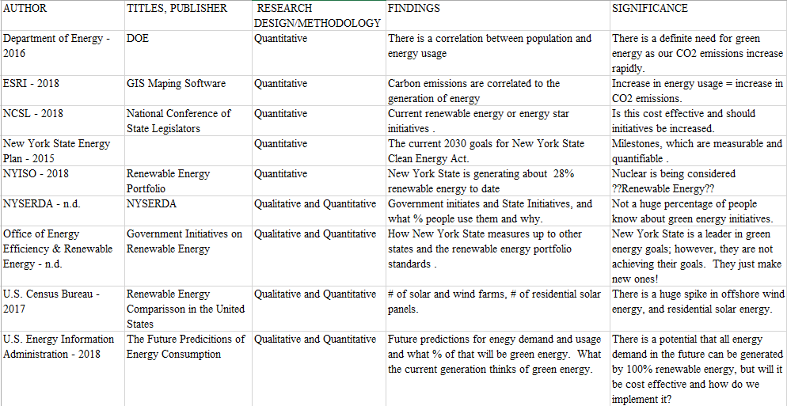
Please Attach a Reference Matrix identifying at least 9 but no more than 12 Key Related Research and Literature Studies That You Plan to Use in Your Dissertation. Include the Following as Columns: A. Author(s) Name, Date; B. Titles, Publisher; C. Research Design/Methodology; D. Findings; E. Significance to YOUR Study; F. Other?

What are the Limitations of Your Proposed Dissertation Study?
There are a few limitations with respect to my research topic:
- People that may not be willing to answer the questions honestly or accurately.
- Lack of access to financial information.
- Minimal response for surveys or questionnaires.
- Lack of participation.
- Inability to get interviews with key people.

What are the Delimitations of Your Proposed Dissertation Study?
Deliminations of my study will be not getting the truth from interviewees. In addition, there may be several interviewees that will refuse to answer key questions limiting my ability to uncover the current state or progress of green energy and carbon emission reductions. Sorting thru political agendas versus actual measurable results will impede my research.
Identify at Least Three “Specific Good Ideas” or “Helpful Suggestions” That You Gained From the December 8, 2018 PhD Research Symposium (cite: presenter, topic, key research concepts) that are Influencing your “Dissertation Thinking” at This Time and State WHY?
1. I had an emergency during the 1st presentation; therefore, I had to leave at approximately 10:30am. I would like to say that the symposium has been a huge success. As a doctorate student, about to write my dissertation, the symposium provides an example of what expect and work it takes to conduct and present your research. The symposium is a great segway for both new and current doctoral students.

