The Future of Green Energy in New York State
Nick E. Gilewski
Advanced Qualitative Methods ADS 830
Dr. Hahn
Niagara University
May 1, 2018

The three ‘papers’ dissertation will render a clear image connecting policy and culture for New York State policy makers, power generators, businesses, and the general public in becoming a green energy state by the year 2030. Depending on the results of the dissertation it may help or hinder the public opinion on New York State’s position and progress on green energy.
With an emphasis on green energy and a green state, New York projects that 50% of electricity generation must come from a renewable source by the year 2030. On April 25, 2018 New York State generated 3,775,682 Mega Watts of power; therefore, in the year 2030 1,887,841 Mega Watts or 50% of power must be generated by a renewable source. On April 25th, 2018 New York State produced 1,230,968 Mega Watts of renewable power, which is 32.6% of the total power generated. Is New York State on an achievable trajectory to meet the goals set by Governor Andrew Cuomo 2030?
Will the demand of power in 2030 grow compared to 2018, and if so by how much? If the demand for electricity generation grows how will New York State remain focused on a goal of 50% renewables by 2030? What are the priorities of New York State when it comes to delivering power and is the environment a priority or consideration? According to the Environmental Protection Agency 28% of the total greenhouse gas emission came from generating electricity (EPA, 2018). With more that a quarter of greenhouse gas emissions coming from generating electricity, New York must steadfast on achieving the goal, which can be done through leadership and policy.
Leadership, policy and government involvement may not be the only contributing factor in achieving the 2030 goal. A cultural shift towards a greener energy conscientious society is essential providing a synergistic effect towards achieving New York States goals in 2030.

The New York State Independent System Operator or NYISO is an organization that is responsible for managing the flow of electricity within New York State. NYISO insures that exact amount of electricity is generated and distributed at exactly the right time by conducting competitive auctions. The competitive auctions on bulk wholesale electricity occur every five minutes every day of the year resulting in the lowest cost power possible in New York State. The NYISO employees approximately 570 people and serves 19.3 million users (NYISO, 2018).
Currently there are a total of 9 Independent Service Operators/Regional Transmission Organizations in the United States and Canada integrating the diverse mix of power resources onto the electric grid. The purpose and goal of the ISOs and RTOs is to ensure access to affordable, reliable and sustainable power though efficient administration of independent and transparent wholesale energy markets. ISO and RTO innovation supports the latest advancements in smart grid technologies, improving resiliency and reliability of the grid, making energy transmission more efficient, smarter and cost effective (ISO/RTO COUNCIL, 2018).

Literature Review
In order to determine the future of going green electrically with respect to policy and leadership, an examination of accredited scholars and researchers’ existing literature is essential. Current trends, policies and theories mostly support and encourage going green electrically. The goals and objectives are to build a clean, resilient, reliable and affordable energy system using digitization and innovation. The National Conference of State Legislatures reports that thirty-seven states, Washington, D.C. and four territories have adopted an RPS (Renewable Portfolio Standard) and or renewable energy goals (Durkay, 2017). See figure 1 for a graphical representation of the renewable portfolio standards or voluntary targets.
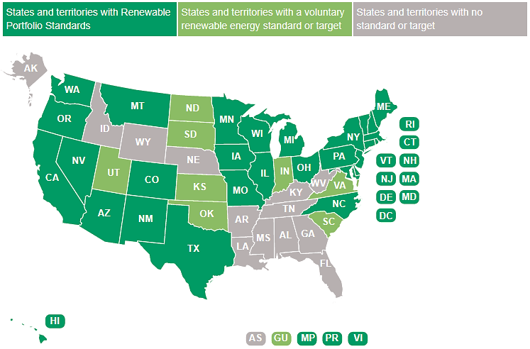
Figure 1 Renewable Portfolio Standards or Voluntary Targets
Source: National Conference of State Legislatures
A renewable portfolio standard or RPS is a regulation that requires the increased production of energy from renewable energy sources, such as wind, solar, biomass, geothermal and in some cases hydro. In short, the renewable portfolio standard mechanism holds electricity supply companies accountable in order to produce more renewable energy. Additionally, the requirement can apply only to investor-owned utilities, but many states also include municipalities and electric cooperatives (Munis and Co-ops), though their requirements are equivalent or lower. (Durkay, 2017). In order for the thirty-seven states, Washington, D.C. and four territories to accomplish such aggressive clean energy goals financial support or government subsidies must be provided. For example, recently I purchased a Chevy Volt which cost about $35,000 new. As part of Governor Cuomo’s clean energy goal to reduce greenhouse gas emissions 40% by 2030 I was New York State provided and Drive Clean Rebate of $1700. In addition to the $1700 from New York State the federal Internal Revenue Service provided me with a tax credit of $7,500. My green vehicle purchase provides the reader with an example that there is a combined effort from the state and federal level in order to go green electrically; supporting my findings, the National Renewable Energy Laboratory explains that there are both Federal and State incentives for the usage and generation of renewable energy.
Approximately 80 percent of the government-wide Mission Innovation investment supports DOE research, development, and demonstration activities across the spectrum of clean energy technologies. FY 2017 DOE highlights include:
- Over $105 million for new innovation initiatives to accelerate the rate of invention and successful commercialization of sustainable transportation, renewable power, and energy efficiency technologies, including expanded innovation partnerships with the National Laboratories;
- Over $110 million for new Regional Clean Energy Innovation Partnerships that will support clean energy R&D solutions targeted to the unique characteristics of each region, and draw upon the strengths of each region's innovation ecosystem;
- Over $261 million for advanced clean energy manufacturing R&D projects and facilities, including two new National Network for Manufacturing Innovation Institutes;
- Over $880 million in cutting-edge sustainable transportation technologies to increase the affordability and convenience of advanced vehicles and domestic renewable fuels;
- Over $500 million to increase the use and reduce the costs of clean renewable power from solar, wind, water, and geothermal energy, including $213 million to support the SunShot Initiative mission to make solar energy fully cost-competitive with traditional energy sources before the end of this decade;
- Over $1.8 billion in basic clean energy research on energy production, conversion, storage, and use, as well on as advancing our understanding of the earth and its climate;
- Over $804 million for programs and infrastructure that support the advancement of nuclear energy technologies, including R&D in advanced nuclear reactor technologies, life extension for existing power plants, and advanced nuclear fuels;
- Over $177 million to support grid modernization, resiliency, and integration of clean energy into the grid; and
- Nearly $564 million in research focused predominantly on development and deployment of carbon capture and storage technologies as well as other approaches to improve the emissions performance of energy generated from fossil fuels.
Source: U.S. Department of Energy
New York State has specific goals to reach by the year 2030. New York State will reduce greenhouse gasses by 40%, decrease energy consumption in buildings by 23% from 2012 levels, and 50% of the electricity generated must come from a renewable source by the year 2030 (New York State Energy Plan, 2015). Figure 2 shows the relationship between all fuels and renewables in the state of New York. Renewable energy currently accounts for approximately 32.3% of the total energy generated to support the New York State grid, which was recorded on March 1, 2018. With that being said, New York State has a little less than 12 years to increase their renewable generation by 17.8%, which is an obtainable goal by 2030.
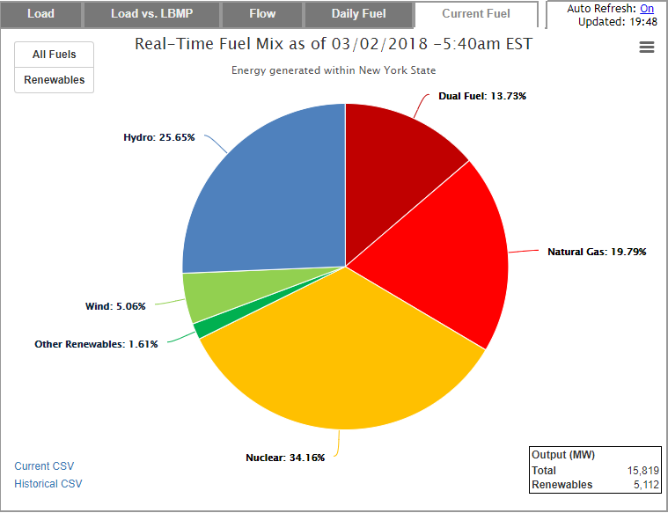
Figure 2 – Real-Time Fuel Mix as of 03/02/2018
Source: New York State Independent System Operator
Comparatively, California’s renewable portfolio requirement is: 33% by the year 2020, 40% by 2027 and lastly, 50% of the power generated by the year 2030 will come from renewable energy. Figure 3 shows the relationship between all fuels and renewables in the state of California. Renewable energy accounts for approximately 15% of the total energy generated to support the Southern part of California’s grid on March 1, 2018. California has a little less than 12 years to increase their renewable generation by 35%, which seems unlikely as demand continues to increase as well.
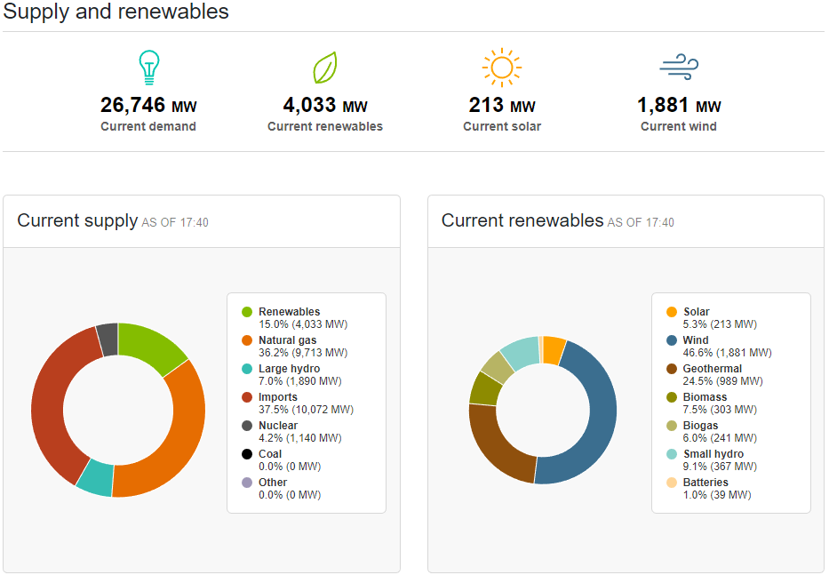
Figure 3 – Southern California Supply and Renewables
Source: The State of California Independent System Operator
Keep in mind as these states move forward in time towards their year 2030 goal, the demand or increase in electricity production is continually increasing with population growth. Figure 4 shows the growth in electricity end usage in the United States from 1973 to 2017. In January of 2015 the United States utilized 326,311 million kilowatt-hours, which is 2.26 times more that was used in January of 1973 at 144,505 million kilowatt-hours of power.
Comparatively, as mentioned over time the population increases; therefore, there is direct correlation to the amount of people and electricity needed for the growing population. Figure 5 shows a continued growth in population from 1920 to 2017. However, it’s not that cut and dry as there are several factors or variables that determine overall electricity usage in the United States. For example, the U.S. economy and manufacturing; the more manufacturing facilities operating the in the U.S. the more power consumed or demanded from the grid. Another example would be inclement weather; extreme hot or cold demands heating or cooling, which create record breaking demand. During the dead of summer when the majority of the U.S. is above 80 degrees thermal constraints and line loss become a major consideration. There are several variables to consider when looking at overall electricity consumption, but a correlation can be made from figure 4 and figure 5, which is that as the population continuous to growth so will the electricity demand and consumption.
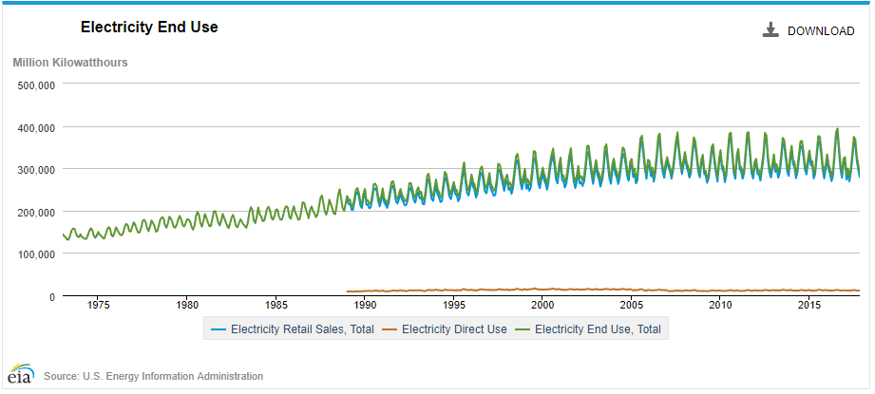
Figure 4 – Electricity End Usage
Source: U.S. Energy Information Administration
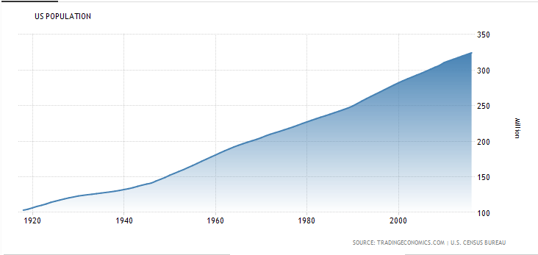
Figure 5 – United States Population
Source: U.S. Census Bureau
There are still unanswered questions, which are “at what rate is the grid going to grow and should we as a society restrict our generation or restrict our consumption?” Either way going green electrically and green renewable energy is imperative to curtail and or support continued growth electrically in order to provide a clean, resilient, reliable and affordable energy system. Lastly, there needs to be a collective effort between both the state and federal entities in order to achieve such monumental goals and objectives.

.

References
Alizada, K. (2012). Diffusion of Renewable Energy Policies. Ann Arbor: ProQuest.
California ISO. (2018, 03 01). Supply and Renewables. Retrieved from California Independent Service Operator: http://www.caiso.com/TodaysOutlook/Pages/supply.aspx
Department of Energy. (2016, February 06). FY 2017 Department of Energy Budget Request Fact Sheet. Retrieved from ENERGY.GOV: https://www.energy.gov/fy-2017-department-energy-budget-request-fact-sheet
Durkay, J. (2017, August 1). State Renewable Portfolio Standards and Goals. Retrieved from National Conference of State Legislatures: http://www.ncsl.org/research/energy/renewable-portfolio-standards.aspx
EPA. (2018, April 24). Sources of Greenhouse Gas Emissions. Retrieved from Environmental Protection Agency: https://www.epa.gov/ghgemissions/sources-greenhouse-gas-emissions
FERC. (2018, April 25). Regional Transmission Organizations (RTO)/Independent System Operatiors (ISO). Retrieved from Federal Energy Regulator Commision: https://www.ferc.gov/industries/electric/indus-act/rto.asp
ISO/RTO COUNCIL. (2018, April 20). The Role of ISOs and RTOs. Retrieved from IRC ISO/RTO COUNCIL: http://www.isorto.org/about/Role
New York State Energy Plan. (2015, 12). Retrieved from New York State: https://energyplan.ny.gov/Plans/2015.aspx
NYISO. (2018, 03 02). Data Graphs and Fuel Mix Chart. Retrieved from New York Independent Service Operator: http://www.nyiso.com/public/markets_operations/market_data/graphs/index.jsp?load=pie
Office of Energy Efficiency & Renewable Energy. (n.d.). Retrieved from Doepartmant of Energy: https://www.energy.gov/eere/wipo/weatherization-and-intergovernmental-program-office-projects-map
Pumpkin TV. (2014). Debating energy futures. Retrieved from Films On Demand: https://fod.infobase.com/PortalPlaylists.aspx?wID=102578&xtid=86418
U.S. Census Bureau. (2017, March 12). United States Population. Retrieved from Trading Economics: https://tradingeconomics.com/united-states/population
Zhou, E. (2015, 10). U.S. Renewable Energy Policy and Industry. Retrieved from National Renewable Energy Laboratory: https://www.nrel.gov/docs/fy16osti/65255.pdf

